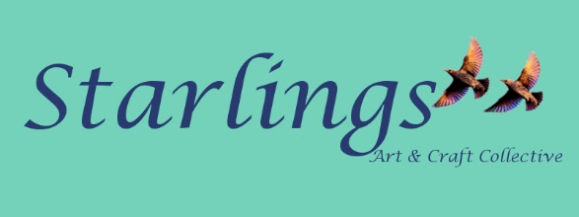

CORONAVIRUS COVID-19

Due to the Coronavirus outbreak we will be closing our shop at 5pm on the 21st of March until further notice.

However, we will continue to trade online at our website, www.starlingsgifts.co.uk or

https://www.facebook.com/Starlingsartandcraftcollective/ or

if you wish to telephone us, we can still take orders over the telephone - Please ring 01424 272554 or virtual shopping via WhatsApp video call 07307 852278.

Some of our artists/ designer makers have offered their details for you to contact them directly if you wish to make any purchase via them as they are self-isolating.

We will also be offering a collection window from every Saturday 12pm-3pm where customers who have placed orders can come and collect their items.

We apologise for any inconvenience this may cause and hope you understand the need to keep safe our members artists and designer makers and our customers in these difficult times.

Starlings Art & Craft Collective,
13 Sackville Road, Bexhill-on-sea.
Starlings Members Contacts List

If you wish to contact any of members directly please feel free to get in touch directly with them.

Charlotte Arundell – Handbags and purses. Products available via Starlings website or telephone: 07944 349285

Phaedra Menas - Leather goods. Products available via www.phaedramenas.com website
Email: phaedramenas@gmail.com
Telephone: 020 77372529 /07904 523335

Unica hand cream and cosmetics/jewellery at www.unicacosmetics.com - Products available via website.

Dorothy and Nigel - Glass Bottle clocks / fused glass and jewellery. Products available via http://www.glassconstructions.co.uk website
Email enquiries@glassconstructions.co.uk or
Telephone: 07970 178233

Moons & Spoons – Jewellery. Products and more info at Facebook: Moons-a-spoon
Email: moons-a-spoon@hotmail.com

Springbok Woodturning Crafts - Products and more info at Email: beatrixfolkard@sky.com
Telephone: 01323501636

Margaret Turton at Beauty Spot Designs. Products available at https://www.beautyspotdesigns.com/
Email info@beautyspotdesigns.com

Beg For Mercy Designs – T-shirts, cushions, tote bags and cards. Products available at www.beg-for-mercy.com
10% of proceeds from website sales goes to animal rescue charities.

Robin Clarke of PhotoArt photography - Products and more info at Email: robpc37@yahoo.co.uk
Telephone: 07792 929478

Vanya Dickinson of Mailles Belle designs – Cushions, towels, cards interiors. Products and more info at
Email: vdickinson143@btinternet.com
Telephone: 01444 248524

James Heighway –Art deco paintings. Products and more info at Jamesheighway@yahoo.co.uk
Telephone: 07731 949692

Miranda Jorndoff - Lino print Artist. Cards, prints, original artwork. Products and more info at wogglebugz@aol.com

Julia Lloyd-Jones Stained Glass Artist – Stained glass artworks, interiors hangings and cards. Products and more info via website www.julialloyd-jones.com
Telephone: 07876 284648

